

HOME REMEDY APP

PROCESS DESIGN DOCUMENT



May 19, 2021

Prepared by: [SaiEsvar, Swathi, Ghetanjali]

Version No: 1.0

Table of Contents

About This Document…………………………………………………………………………………………………………………………………………….1

1 Overview……………………………………………………………………………………………………………………………………………2

1.2 Current Process Stats 2

2 Process Flow 2

2.1. Scope 2

2.1.1 Activities in scope 2

2.2 To Be process flow diagram 3

2.3 Deployment Design 3

# About This Document

The Process Design Document describes in detail the business processes chosen for automation and the design approach for the robot being developed using the approved Robotic Process Automation (RPA) Tool.

The document describes the sequence of steps performed as part of the process, the conditions, rules & exceptions of the process prior to and after automation. This design document serves as a base documentation to under the details required for robotic automation of the same business process.

Document Revision History

This section records the history of significant changes to this document. Only the most significant changes are described here. Where significant changes are made to this document, the version number will be incremented by 1.0. Minor changes made for clarity and reading purposes, where no change is made to the meaning or intention of this document, will be indicated by a 0.1 increase in the version number.

|  |  |  |  |
| --- | --- | --- | --- |
| Version | Version Date | Revision Comments | Author |
| 1.0 | 5/18/2021 | First Draft | Sai Esvar.P |

# 1 Overview

First aid app is an application used to get the health issues as an input from the user and give the home remedies as its result

## 1.2 Current Process Stats

|  |  |
| --- | --- |
| **Function** | Health care |
| **Department** | Medical |
| **Role required for performing the process** | Person with health issue |
| **Process scheduled** | When required |
| **Input data** | Health issue |
| **Output data** | Home remedies |

# 

# 2 Process Flow

## 2.1. Scope

The activities and exception in of scope for RPA, in this automation workflow/sequence are listed here.

### 

### 2.1.1 Activities in scope

|  |  |  |
| --- | --- | --- |
| **Process Name** | **Activities** | **Owner** |
| First aid app | Enter Health Issue |  |
|  | Click submit |  |
|  | Search for required health issue |  |
|  | Scrap the home remedies |  |
|  | Generating the defined output |  |

## 2.2 To Be process flow diagram

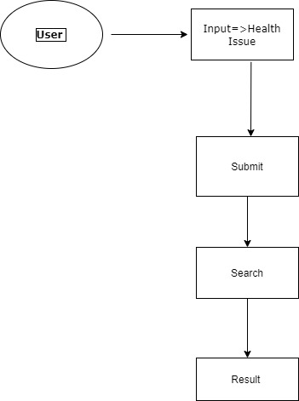

Detailed Steps to be performed by robot:

The activities and exception in of scope for RPA, in this automation workflow or sequence are listed here.

Step 1: Get the input from the user (Health Issue)

Step2: Open the browser (www.google.com) and search the given health issue.

Step3: Scrap the home remedies from the Google.

Step4: Bot will return to main page.

Step5: Display the result.

## 2.3 DEPLOYMENT DESIGN

Search the home remedies for the health issues. Robot will be search and generate the proper result of home remedies for the given health problems by run the process.